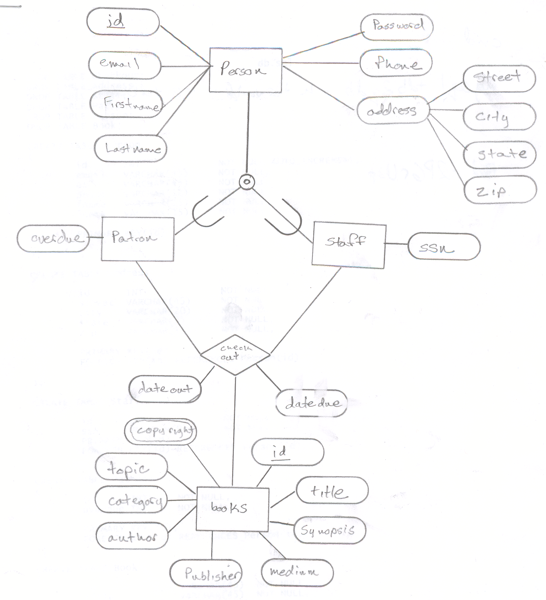
CREATE TABLE Person
(
id INT NOT NULL AUTO_INCREMENT,
email VARCHAR(45) NOT NULL,
pwd VARCHAR(45) NOT NULL,
phone VARCHAR(12) NOT NULL,
fname VARCHAR(15) NOT NULL,
lname VARCHAR(15) NOT NULL,

PRIMARY KEY(id)

);

CREATE TABLE Address
(
id INT NOT NULL,
street VARCHAR(45) NOT NULL,
city VARCHAR(20) NOT NULL,
state VARCHAR(2) NOT NULL,
zip VARCHAR(12) NOT NULL,

PRIMARY KEY(id),
FOREIGN KEY(id) REFERENCES Person(id)

);

CREATE TABLE Staff
(
id INT NOT NULL,
ssn VARCHAR(9) NOT NULL,
PRIMARY KEY(id),
FOREIGN KEY(id) REFERENCES Person(id)
);

CREATE TABLE Patron
(
id INT NOT NULL,
overdue FLOAT DEFAULT '0'
CHECK (overdue >= 0.0),

PRIMARY KEY(id),
FOREIGN KEY(id) REFERENCES Person(id)
);

CREATE TABLE Book
(
id VARCHAR(45) NOT NULL,
title VARCHAR(45) NOT NULL,
synopsis VARCHAR(1000) NOT NULL,
topic VARCHAR(20) NOT NULL,
category VARCHAR(20) NOT NULL,
author VARCHAR(30) NOT NULL,
publisher VARCHAR(45) NOT NULL,
copyright VARCHAR(4) NOT NULL,

PRIMARY KEY(id)
);

CREATE TABLE Checkout
(
sid INT NOT NULL,
pid INT NOT NULL,
bid VARCHAR(45) NOT NULL,
dateout DATETIME NOT NULL,

PRIMARY KEY(sid, pid, bid),
FOREIGN KEY(sid) REFERENCES Staff(id),
FOREIGN KEY(pid) REFERENCES Patron(id),
FOREIGN KEY(bid) REFERENCES Book(id)
);

INSERT INTO Person (email, fname, lname, pwd, phone)
VALUES ("tdb2q@mtsu.edu", "Timothy", "Beckett", "12345", "1234566789");

INSERT INTO Address (id, street, city, state, zip)
VALUES ( 1, “123 main st”, “Winchester”, “TN”, “37398”);

INSERT INTO Patron (id)
VALUES ( 1 );

INSERT INTO Staff(id, ssn)
VALUES (id, “123456789”);

INSERT INTO Book (id, title, synopsis, publisher, author, category, topic, copyright)
VALUES (“1111.11”, “The Chronicles of Narnia”, “four children travel repeatedly to a world in which they are far more than mere children and everything is far more than it seems.”, “HarperCollins” , “C.S. Lewis”, “Fantasy”, “NA”, “1954”);

